1) generate a red license key for snowflake as below

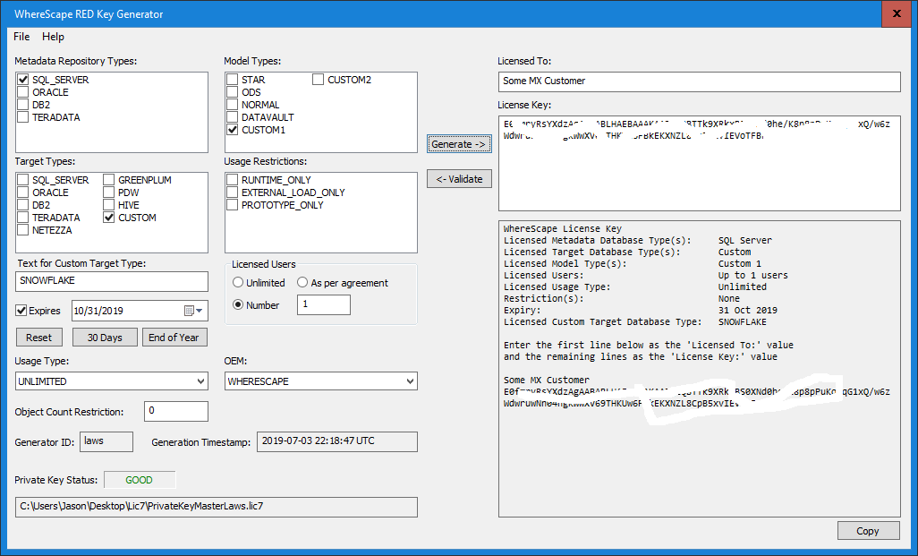

2) generate a 3D license key for EXACTLY the same company as below

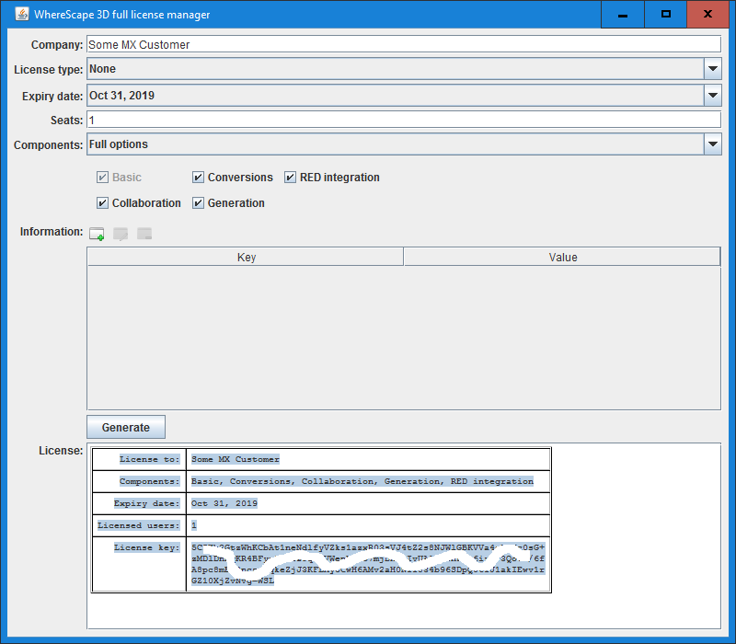

3) close 3D key generator (as it does not release the lock on its log file until you do)

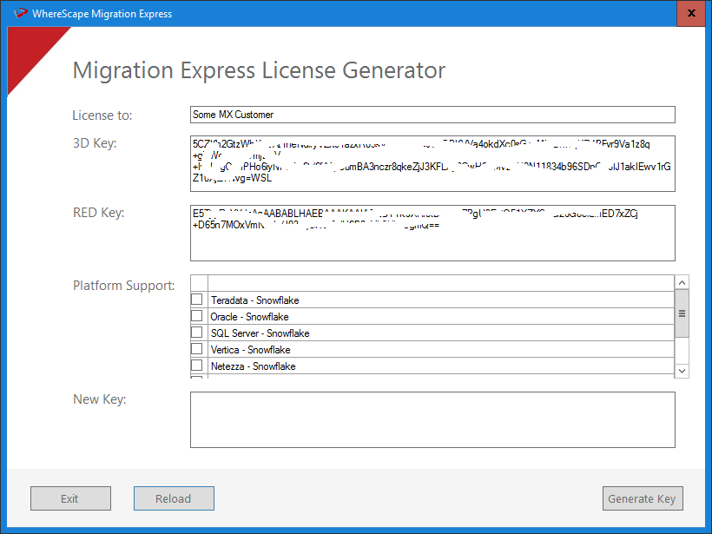

4) generate a MX license key as below

----> it will be filled in with details in first MX key screen shot automatically

----> all you have to do is check the legacy databases you want then click Generate

